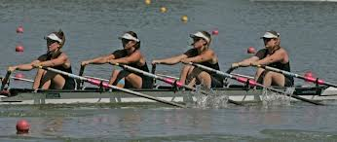
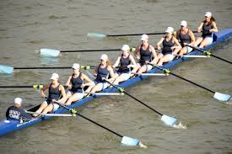
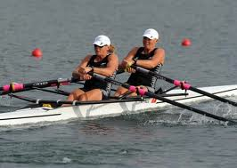

TWO! FOUR! ALSO, EIGHT!

TRY A SPORT THAT’S REALLY GREAT!

Learn to row this summer!
Come have fun with Mercy Crew!

If you are a student entering grades 8 through 12 this fall,
please consider learning to row this summer!
(NOTE: young women who might want to row for Mercy Crew in the fall are STRONGLY ENCOURAGED to attend at least ONE Learn to Row session!)

2017 Session Information

Session 1: June 26 – July 7 10:00 am – 12:00 pm (daily)

Session 2: August 14 – August 25 10:00 am – 12:00 pm (daily)

Sessions are held at the Genesee Waterways Center (GWC) in Genesee Valley Park. (See map.)

Cost

$225 per session
Checks payable to Mercy Crew Inc.

Additional Information

For more information, email coachmark@mercycrew.org.
Parents must sign a waiver on the first day of camp.
To register, complete the form on the back of this page and mail to: Mercy Crew, Inc., PO Box 10582, Rochester, NY 14610.

Registration Form
- - - - - - - - - - - - - - - - - - - - - - - - - - - - - - - - - - - - - - - - - - - - - - - - - - - - - - - - - - - - - - - - - - - - - - - - - - - - - - - - - - - - - -

Student Name___________________________________ Age_______ Grade in Fall_______
Address______________________________________________________________________________
Parent email address_________________________________________________________________
Home phone__________________________ Parent cell phone_______________________
School student currently attends___________________________________________________
School student will attend in the fall______________________________________________
Registration for Session:
_____ Session 1: June 26 – July 7

_____ Session 2: August 14 - 25

Directions to the GWC Boathouse

Address: Phone: 585-328-3960
149 Elmwood Avenue
Rochester, New York 14611

GWC is located in Genesee Valley Park beyond the City ice rink/outdoor pool:

- From I-390, get off at the Scottsville Road (NYS Rt. 383) exit which is on the southwest side of Monroe County.
- Travel north on Scottsville Road for about 2/3 mile and then bear right onto Elmwood Ave.
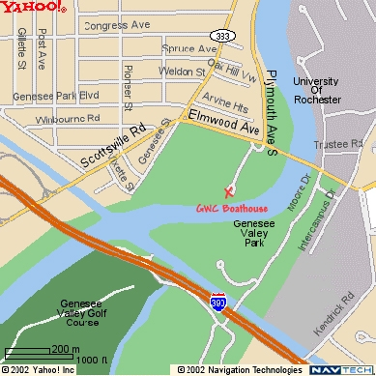
- Proceed ¼ mile on Elmwood Ave and turn right into Genesee Valley Park by the City ice arena/pool. Go another 400 feet until you see the GWC facilities (tan and green buildings) and park in the designated areas.

